**Naveen Bonala  Task for terraform-01**

1. Install Terraform on your PC

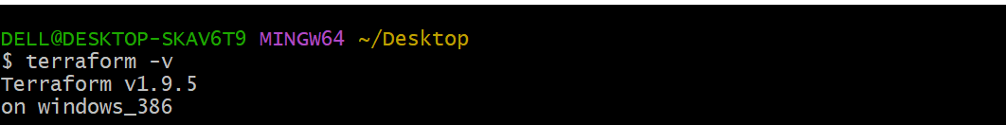

1. Execute all the templates shown in video.

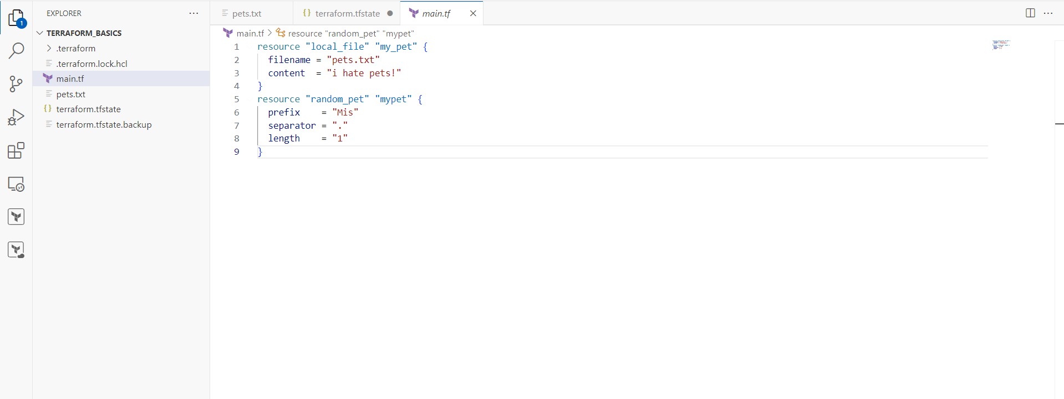

3) Note down below points,

Terraform Init

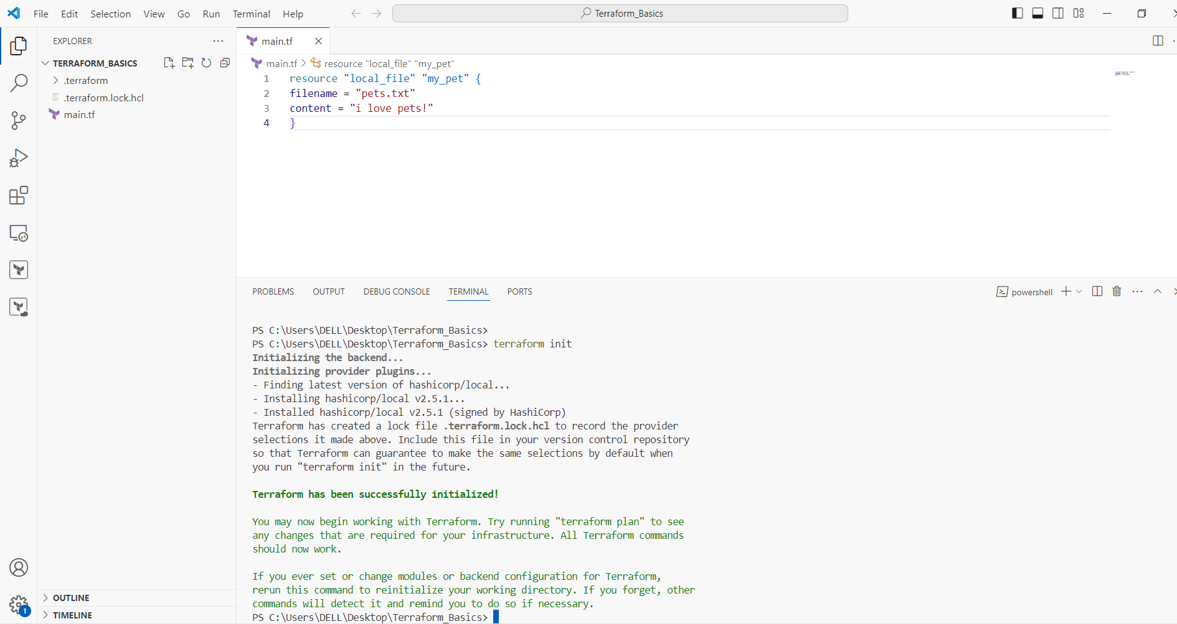

Terraform Plan

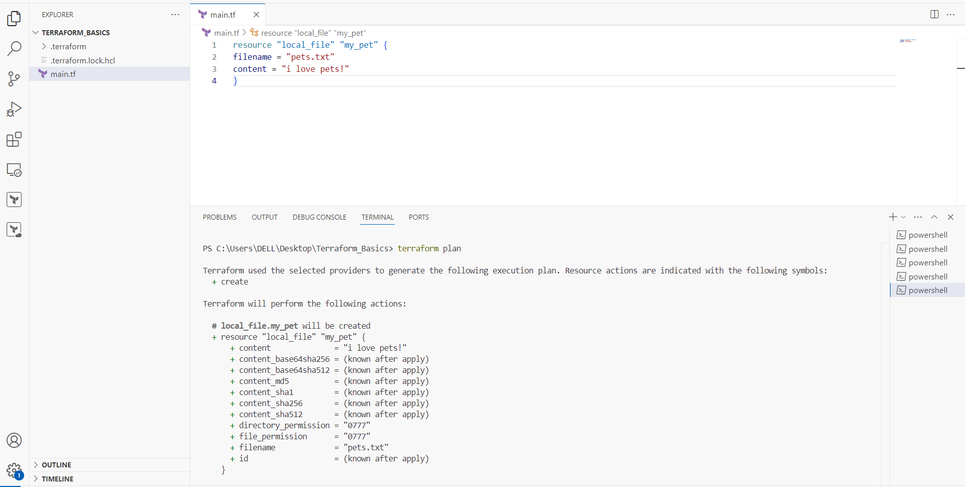

Terraform Apply

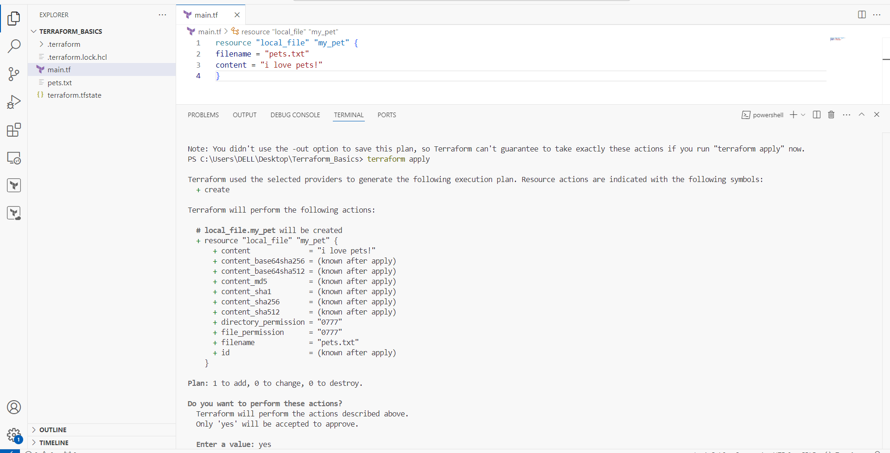

Terraform Providers.

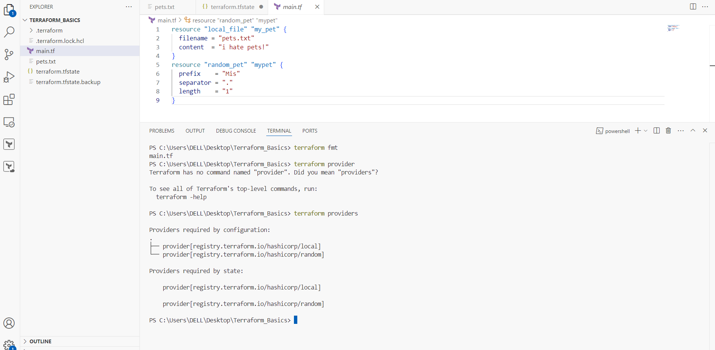

4) Integrate a sample Terraform template in jenkins.